CEL 51, DCCN, Monsoon 2020
Lab 2: Basic Network Utilities

This lab introduces some basic network monitoring/analysis tools. There are a few exercises along the way. You should write up answers to the ping and traceroute exercises and turn them in next lab. (You should try out each tool, whether it is needed for an exercise or not!).

Prerequisite: Basic understanding of command line utilities of Linux Operating system.

Some Basic command line Networking utilities

Start with a few of the most basic command line tools. These commands are available on Unix, including Linux (and the first two, at least, are also for Windows). Some parameters or options might differ on different operating systems. Remember that you can use man <command> to get information about a command and its options.

ping — The command ping <host> sends a series of packets and expects to receieve a response to each packet. When a return packet is received, ping reports the round trip time (the time between sending the packet and receiving the response). Some routers and firewalls block ping requests, so you might get no reponse at all. Ping can be used to check whether a computer is up and running, to measure network delay time, and to check for dropped packets indicating network congestion. Note that <host> can be either a domain name or an IP address. By default, ping will send a packet every second indefinitely; stop it with Control-C

Network latency, specifically round trip time (RTT), can be measured using ping, which sends ICMP packets. The syntax for the command in Linux or Mac OS is:
ping [-c <count>] [-s <packetsize>] <hostname>

The syntax in Windows is:

ping [-n <count>] [-l <packetsize>] <hostname>

The default number of ICMP packets to send is either infinite (in Linux and Mac OS) or 4 (in Windows). The default packet size is either 64 bytes (in Linux) or 32 bytes (in Windows). You can specify either a hostname (e.g., spit.ac.in) or an IP address.

To save the output from ping to a file, include a greater than symbol and a file name at the end of the command. For example:
ping -c 10 google.com > ping_c10_s64_google.log

Experiments with Ping
- Ping the any hosts 10 times (i.e., packet count is 10) with a packet size of 64 bytes, 100 bytes, 500 bytes, 1000 bytes, 1400 bytes
Result

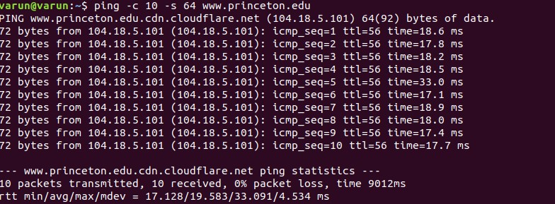

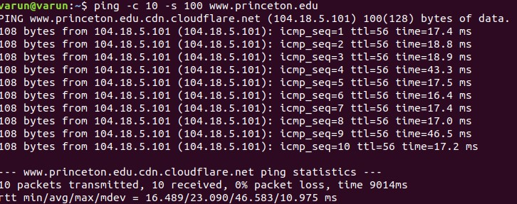

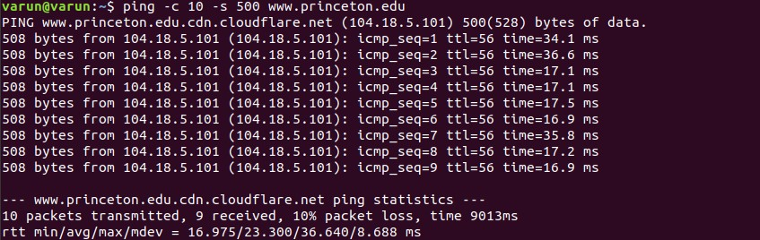

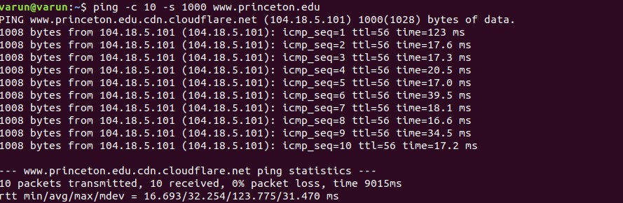

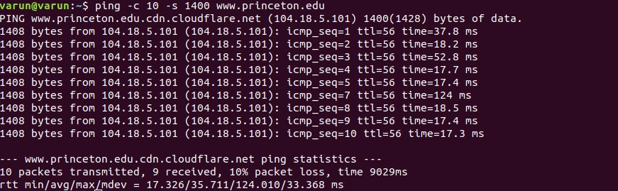

Using Ping for different sites
- Using ping with default packet size of 64 bytes

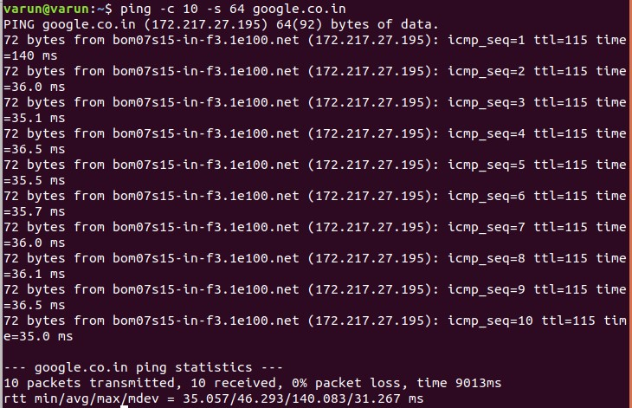

- Using ping with a packet size of 100 bytes:
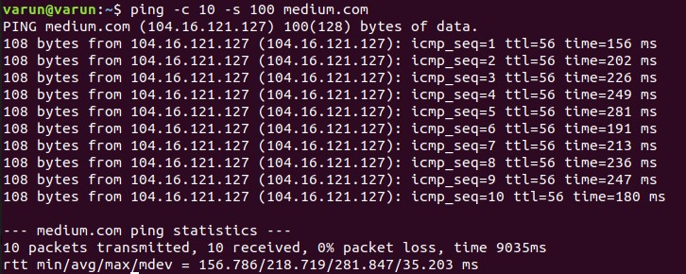
- Using ping with a packet size of 500 bytes:
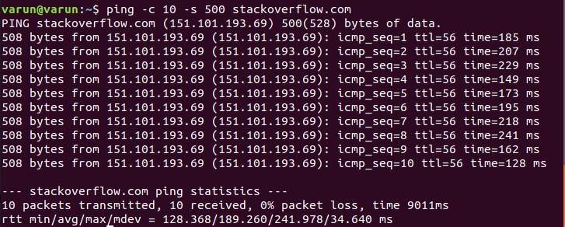

- Using ping with a packet size of 1000 bytes
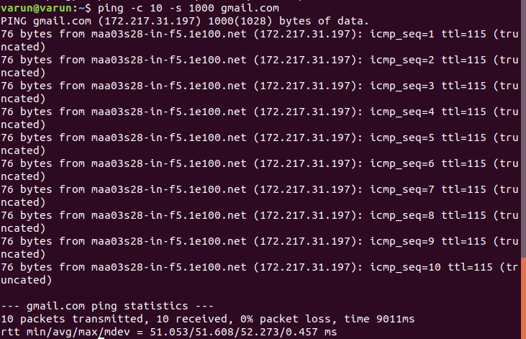
- Using ping with a packet size of 1400 bytes:

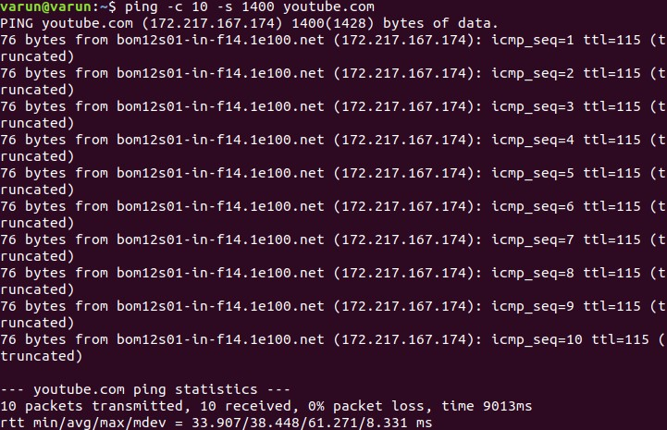
Questions About Latency
Now look at the results you gathered and answer the following questions about latency. Store your answers in a file named ping.txt.
- Does the average RTT vary between different hosts? What aspects of latency (transmit, propagation, and queueing delay) might impact this and why?
Average RTT can vary between different hosts due to Processing delay, queuing delay,
Transmission delay , and Propagation delay.

• Processing delay – time it takes a router to process the packet header, depends on the
processing speed of the switch
• Queuing delay – time the packet spends in routing queues depends on the number of
packets, size of the packet and bandwidth
• Transmission delay – time it takes to push the packet's bits onto the link depends on
size of the packet and the bandwidth of the network.
• Propagation delay – time for a signal to reach its destination depends on distance and
propagation speed.
Thus the different average RTT values of amazon.com and google.com can be because of the above mentioned factors.

- Does the average RTT vary with different packet sizes? What aspects of latency (transmit, propagation, and queueing delay) might impact this and why?
Ans: Yes, the average RTT increases with packet size as queuing, transmission delay increases as they rely on size of packets eventually increasing the average RTT.

Exercise 1: Experiment with ping to find the round trip times to a variety of destinations. Write up any interesting observations, including in particular how the round trip time compares to the physical distance. Here are few places from who to get replies: www.uw.edu, www.cornell.edu, berkeley.edu, www.uchicago.edu, www.ox.ac.uk (England), www.u-tokyo.ac.jp (Japan).
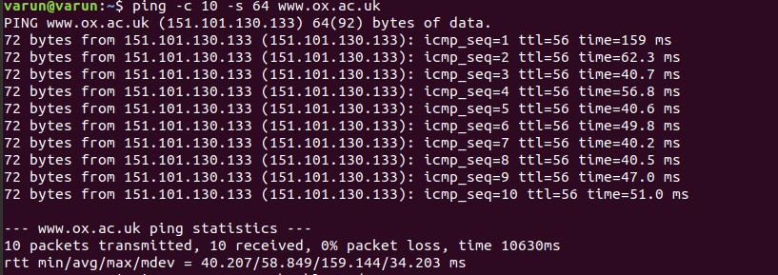

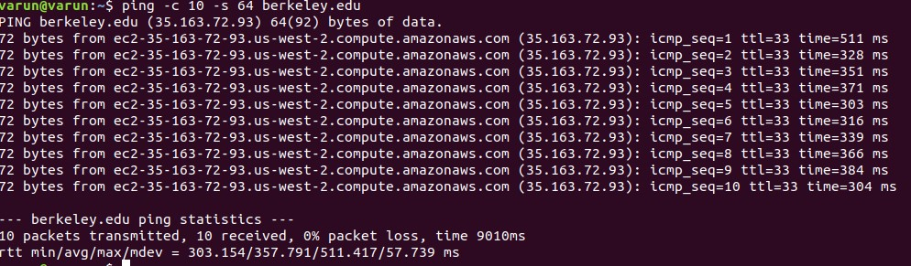

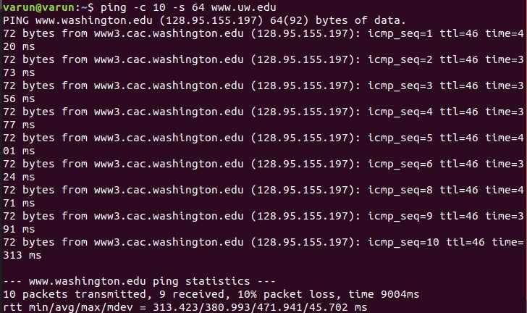

There are certain factors that can bring huge changes in the value of RTT. These are enlisted
below:

- The nature of the transmission medium - the way in which connections are made affects
how fast the connection moves; connections made over optical fiber will behave
differently than connections made over copper. Likewise, a connection made over a
wireless frequency will behave differently than that of a satellite communication.
- Local area network (LAN) traffic - the amount of traffic on the local area network can
bottleneck a connection before it ever reaches the larger Internet. For example, if many
users are using streaming video service simultaneously; round-trip time may be inhibited even though the external network has excess capacity and is functioning normally.
- Server response time – the amount of time it takes a server to process and respond to a
request is a potential bottleneck in network latency. When a server is overwhelmed with requests, such as during a DDoS attack, its ability to respond efficiently can be inhibited, resulting in increased RTT.
- Node count and congestion – depending on the path that a connection takes across the
Internet, it may be routed or “hop” through a different number of intermediate nodes.
Generally speaking, the greater the number of nodes a connection touches the slower it
will be. A node may also experience network congestion from other network traffic, which will slow down the connection and increase RTT.
- Physical distance – although a connection optimized by a CDN can often reduce the
number of hops required to reach a destination, there is no way of getting around the
limitation imposed by the speed of light; the distance between a start and end point is a
limiting factor in network connectivity that can only be reduced by moving content closer to the requesting users. To overcome this obstacle, a CDN will cache content closer to the requesting users, thereby reducing RTT.
Thus the round trip times varies due to these factors

nslookup — The command nslookup <host> will do a DNS query to find and report the IP address (or addresses) for a domain name or the domain name corresponding to an IP address. To do this, it contacts a "DNS server." Default DNS servers are part of a computer's network configuration. (For a static IP address in Linux, they are configured in the file /etc/network/interfaces that you encountered in the last lab.) You can specify a different DNS server to be used by nslokup by adding the server name or IP address to the command: nslookup <host> <server>

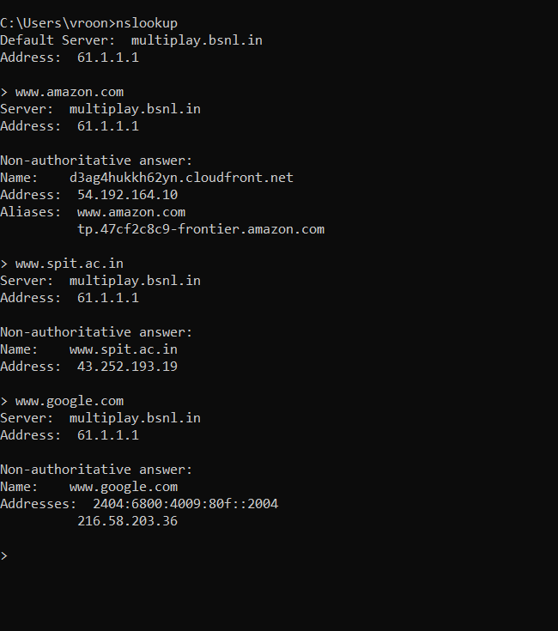

ifconfig — You used ifconfig in the previous lab. When used with no parameters, ifconfig reports some information about the computer's network interfaces. This usually includes lo which stands for localhost; it can be used for communication between programs running on the same computer. Linux often has an interface named eth0, which is the first ethernet card. The information is different on Mac OS and Linux, but includes the IP or "inet" address and ethernet or "hardware" address for an ethernet card. On Linux, you get the number of packets received (RX) and sent (TX), as well as the number of bytes transmitted and received. (A better place to monitor network bytes on our Linux computers is in the GUI program System Monitor, if it is installed!!!.)

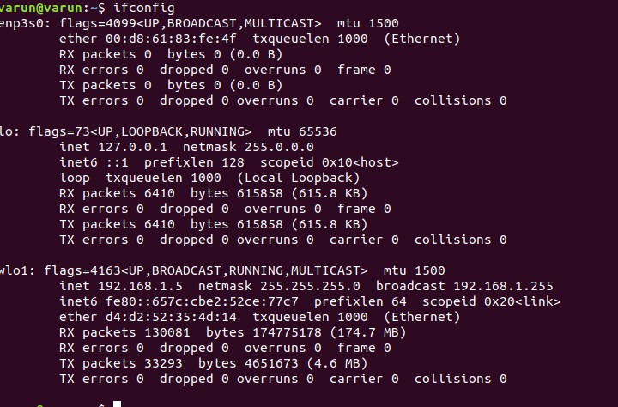

netstat — The netstat command gives information about network connections. I often use netstat -t -n which lists currently open TCP connections (that's the "-t" option) by IP address rather than domain name (that's the "-n" option). Add the option "-l" (lower case ell) to list listening sockets, that is sockets that have been opened by server programs to wait for connection requests from clients: netstat -t -n -l. (On Mac, use netstat -p tcp to list tcp connections, and add "-a" to include listening sockets in the list.).

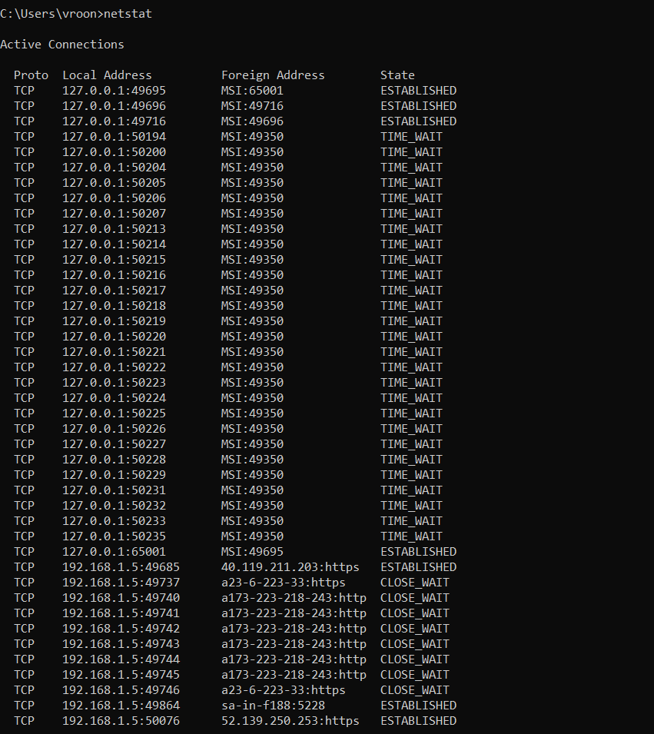

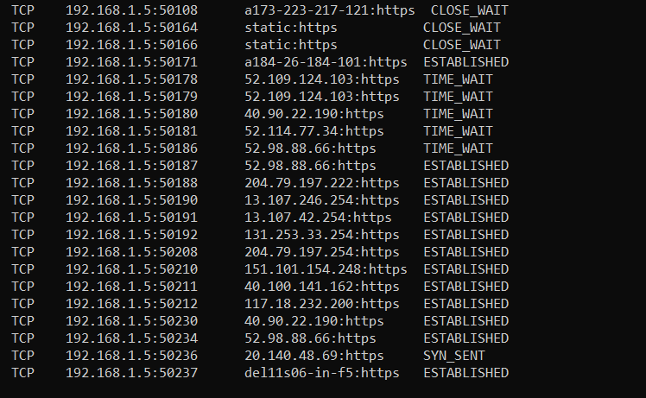

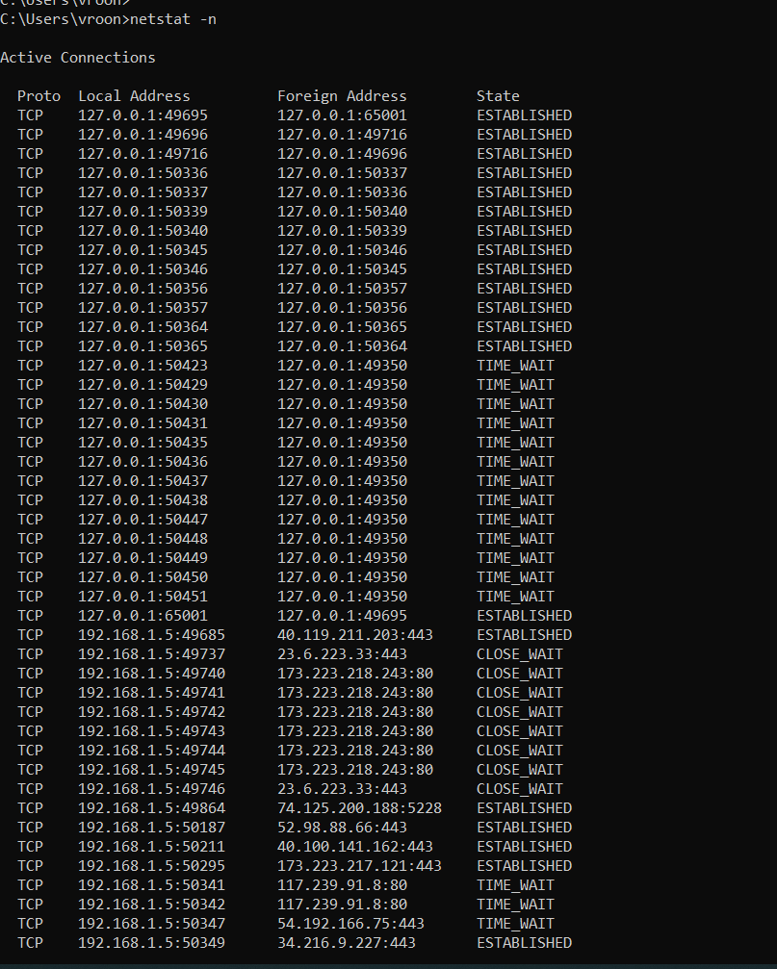

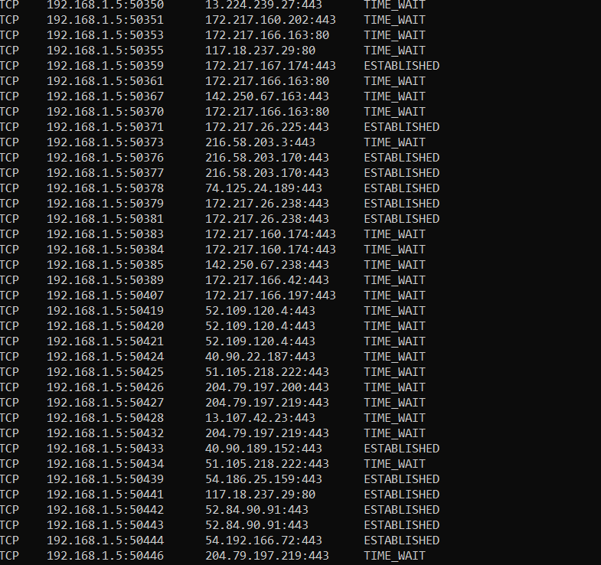

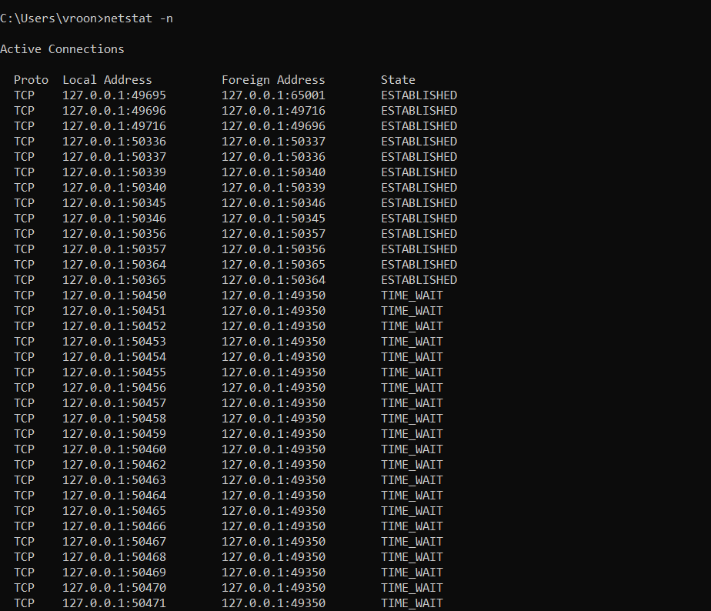

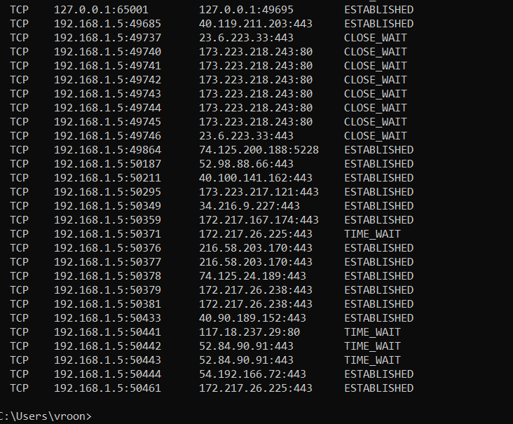

traceroute — Traceroute is discussed in man utility. The command traceroute <host> will show routers encountered by packets on their way from your computer to a specified <host>. For each n = 1, 2, 3,..., traceroute sends a packet with "time-to-live" (ttl) equal to n. Every time a router forwards a packet, it decreases the ttl of the packet by one. If the ttl drops to zero, the router discards the packet and sends an error message back to the sender of the packet. (Again, as with ping, the packets might be blocked or might not even be sent, so that the error messages will never be received.) The sender gets the identity of the router from the source of the error message. Traceroute will send packets until n reaches some set upper bound or until a packet actually gets through to the destination. It actually does this three times for each n. In this way, it identifies routers that are one step, two steps, three steps, ... away from the source computer. A packet for which no response is received is indicated in the output as a *.

Traceroute is installed on the computers. If was not installed in your virtual server last week, but you can install it with the command sudo apt-get install traceroute

The path taken through a network, can be measured using traceroute. The syntax for the command in Linux is:
traceroute <hostname>

The syntax in Windows is:

tracert <hostname>

You can specify either a hostname (e.g., cs.iitb.ac.in) or an IP address (e.g., 128.105.2.6).

1.2.1 Experiments with Traceroute
From your machine traceroute to the following hosts:
- www.cs.grinnell.edu
- csail.mit.edu
- cs.stanford.edu
- cs.manchester.ac.uk
Store the output of each traceroute command in a separate file named traceroute_HOSTNAME.log, replacing HOSTNAME with the hostname for end-host you pinged
(e.g., traceroute_ee.iitb.ac.in.log).

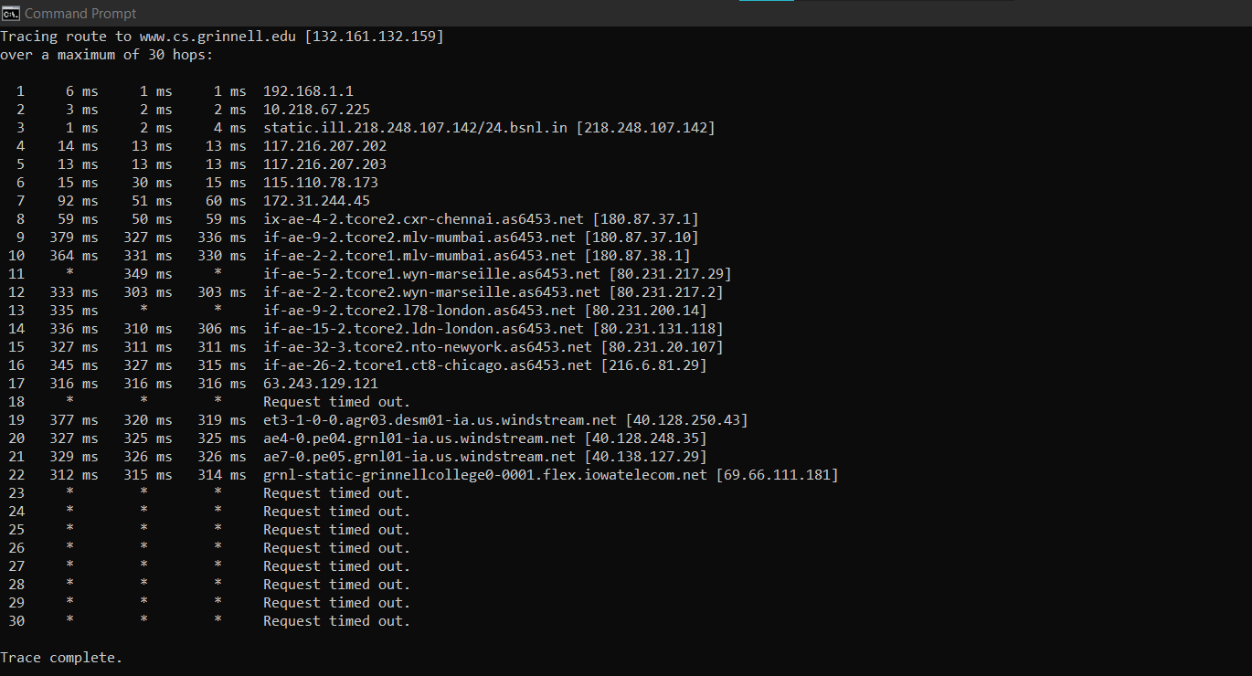

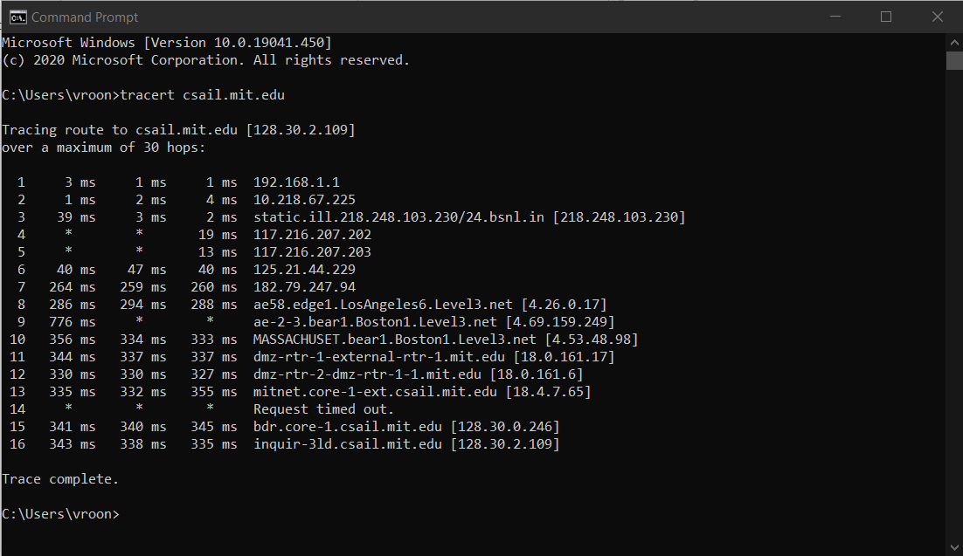
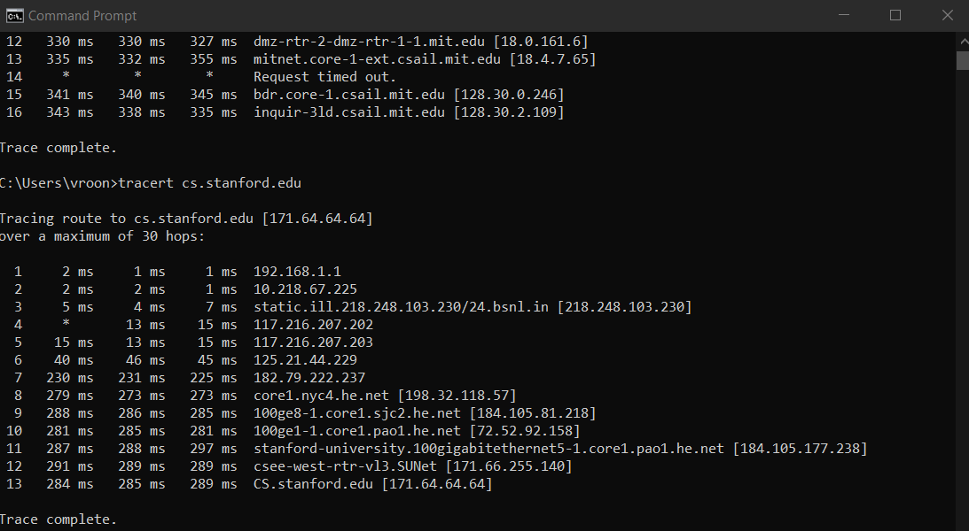

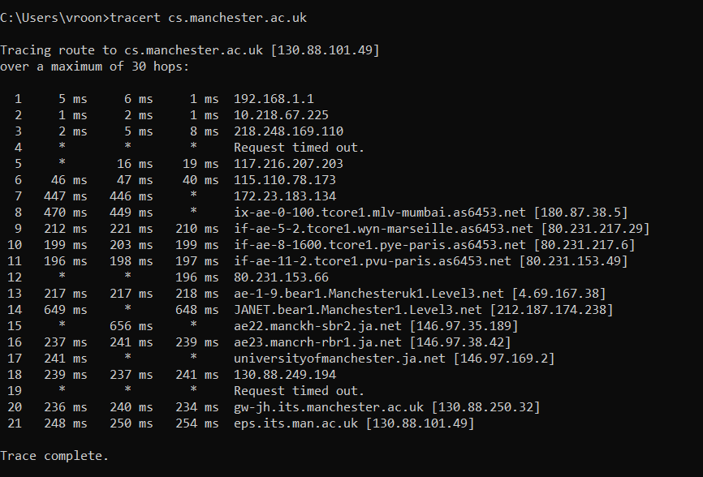

Exercise 2: (Very short.) Use traceroute to trace the route from your computer to math.hws.edu and to www.hws.edu. Explain the difference in the results.
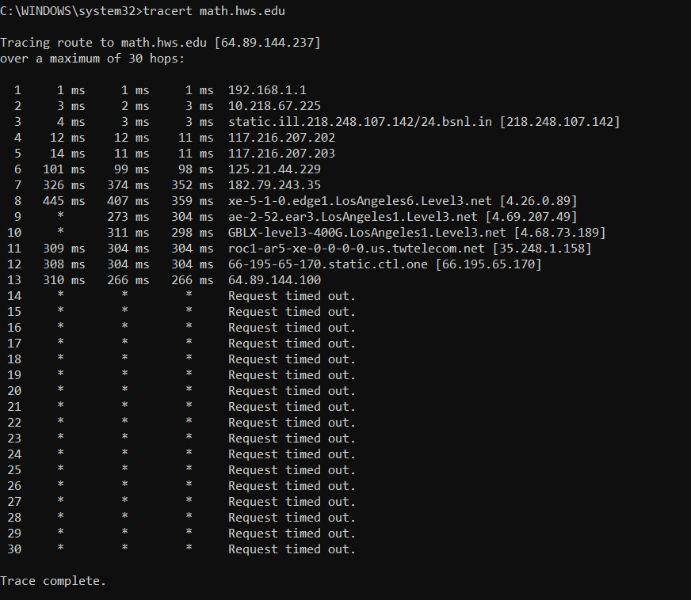

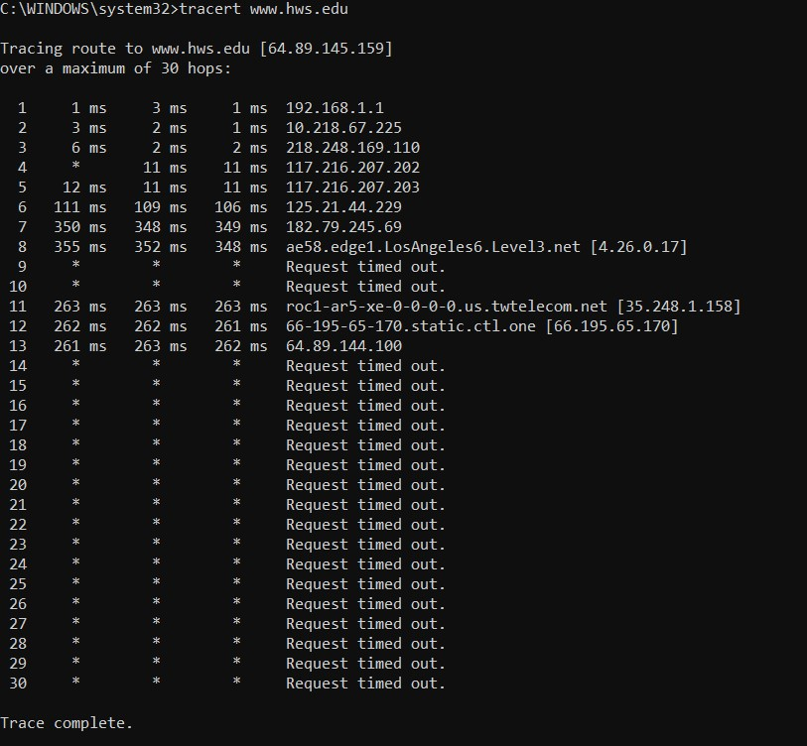

From the above images, the first row shows that the process of route tracing has started as the last column shows the Default Gateway of the user. The next three rows in both the cases are similar as the route is being traced starting from the ISP (Internet service provider) of the user. The next few rows, after which the tracing reaches the common IP address of 66.195.65.170 and then [64.89.144.100], clearly show that the route is completely different after crossing the ISP for both the cases. A domain name might have multiple IP addresses associated. If this is the case, multiple traces may access two or more IP addresses. This will yield trace paths that differ from one another, even if the origin and destinations are the same.
Domains may also use multiple servers for its subdomains. Tracing the path to the base domain might result in a completely different path when tracing to the subdomain. A URL with the www prefix is technically a subdomain, so it’s possible that traces to example.com and www.example.com follow two very different paths.
Many domains use separate hosting for email. If you try to trace the domain, you’ll get data for the website server, not the email server. This concept is popularly known as Caveats

Exercise 3: Two packets sent from the same source to the same destination do not necessarily follow the same path through the net. Experiment with some sources that are fairly far away. Can you find cases where packets sent to the same destination follow different paths? How likely does it seem to be? What about when the packets are sent at very different times? Save some of the outputs from traceroute. (You can copy them from the Terminal window by highlighting and right-clicking, then paste into a text editor.) Come back sometime next week, try the same destinations again, and compare the results with the results from today. Report your observations.

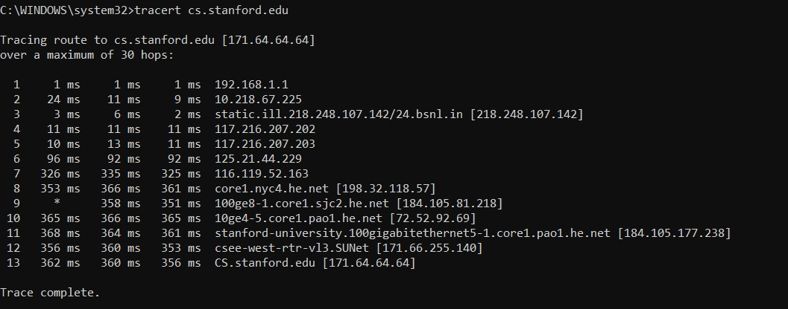

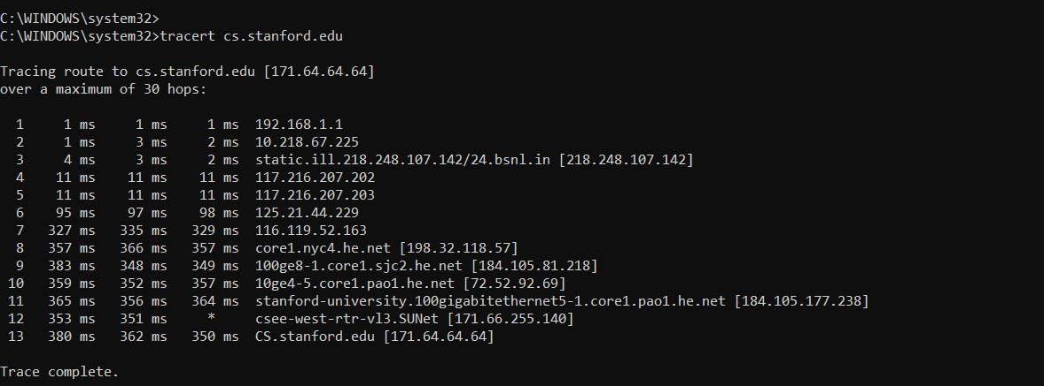

Questions About Paths
Now look at the results you gathered and answer the following questions about the paths taken by your packets. Store your answers in a file named traceroute.txt.
- Is any part of the path common for all hosts you tracerouted?
Yes, the tracerouting follows a particular path from the user’s IP address through the IP addresses of the ISP and then the path really depends on which access point is ready to respond and which access points or routers have firewalls configured for blocking the requests and accordingly, the destination can be reached through different paths at different times.
- Is there a relationship between the number of nodes that show up in the traceroute and the location of the host? If so, what is this relationship?
No, the number of nodes and the location of the host are not related to each other. It even depends on the physical interface that is being used.

- Is there a relationship between the number of nodes that show up in the traceroute and latency of the host (from your ping results above)? Does the same relationship hold for all hosts?
There is a direct relationship between the number of nodes (number of hops minus 1)and the latency of the host. It also depends on the packet size. The amount of latency is largely dependent on how far the visitor is from the server location and how many nodes the signal has to travel through.

CONCLUSION
- Learnt about some basic command line network utilities.
- Learnt about Network Latency, RTT and the factors impacting RTT.

